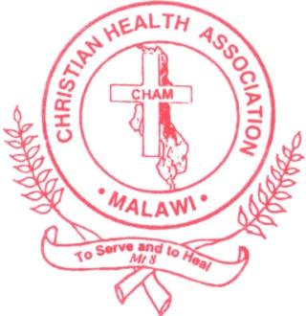
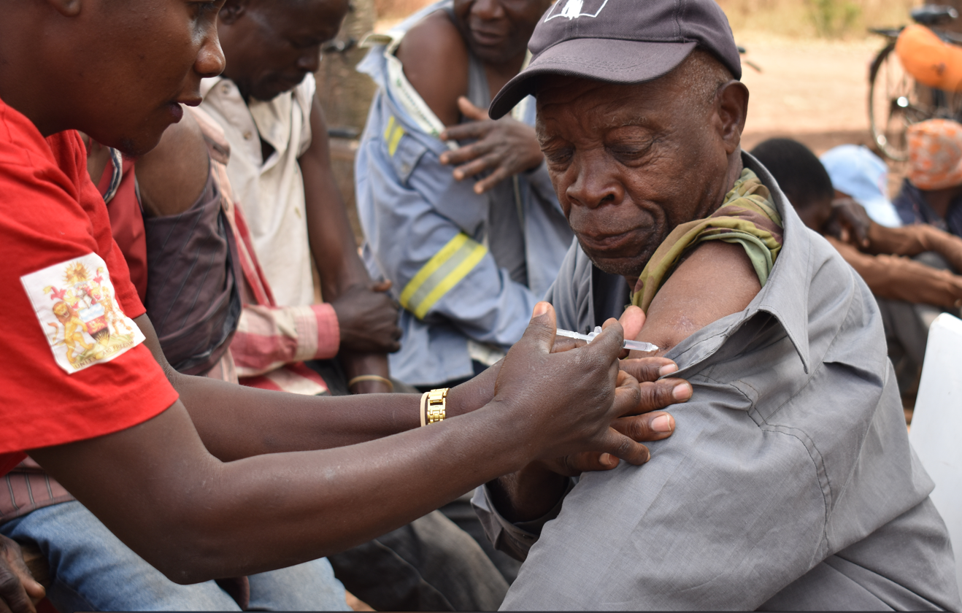
CHAM VAN Project Final Report 2022-2023
Christian Health Association of Malawi 25th January, 2024

Table of Contents
List of abbreviations 2
Executive Summary 3
Key achievements 4
Partner profiles 6
A. Summary of major activities 6
Planning & coordination with MOH 6
Demand creation 8
Vaccine service delivery 9
Integration of Covid-19 Vaccines with routine health services 9
Capacity building 10
Successes 13
Lessons Learnt 15
Strategic changes and future landscape 16
Challenges 16
Recommendations 19
Conclusion 19
Data Tables 20
Country Highlights 22
Pictorial Focus 25

List of abbreviations
CHAM Christian Health Association of Malawi
VAN Vaccine Action Network
DHMT District Health Management Team
ADC Area Development Committees
VHC Village Health Committees
RCCE Risk Communication and Community Engagement
NCD Non-Communicable Diseases
DHO District Health Office
CHW Community Health Worker
CHV Community Health Vaccinators
FP Family Planning
HPV Human Papillomavirus
MOH Ministry of Health
DEC District Executive Committee
MOU Memorandum of Understanding
NGORA Non-governmental Organizations Regulatory Authority
EPI Expanded Program for Immunization
HMIS Health Management Information System
HSA Health Surveillance Assistant
DIP District Implementation Plan
HES Health Education Services
IEC Information, Education and Communication
OHSP One Health Surveillance Platform
DHIS District Health Information Software
MR Measles and Rubella
TCV Typhoid Conjugate Vaccine
T/A Traditional Authority
GVH Group Village Headman
WHO World Health Organization

Executive Summary
Christian Health Association of Malawi (CHAM) was subcontracted by AMREF Health Africa with support from Rockefeller Foundation to implement a Covid-19 vaccine uptake project titled “The Vaccine Action Network (VAN)”. The goal of the project was to increase Covid-19 vaccine uptake among eligible population in Phalombe and Chiradzulu districts by targeting priority gaps and locations, strengthening overall immunization program, building local capacity and using local knowledge. The two districts were among the bottom 5 districts with the lowest Covid-19 vaccination rates in Malawi as of December 2022.
CHAM implemented a range of activities from Dec 2022-Dec 2023 to support Covid-19 vaccination efforts in Chiradzulu and Phalombe districts of Malawi. Working closely with District Health Management Teams (DHMTs), healthcare workers, Area Development Committees (ADCs), Village Health Committees (VHCs) and community influencers (faith, political and traditional leaders). CHAM focused on awareness-raising, service delivery, capacity building, and data management to drive vaccine uptake.
Notable achievements include over 33,000 (136%) Covid-19 vaccine doses administered against a project target of 24,000 and 14,000 (175%) people fully vaccinated against a project target of 8,000. Community engagement activities reached over 270,000 people, while door-to-door campaigns covered 41,780 households. Training in Risk Communication and Community Engagement (RCCE) package and data management equipped community health workers and community influencers in creating demand for Covid-19 Vaccine amongst the residents.
Integrated medical outreaches provided 1,300 women with family planning services and screened over 1,200 people for hypertension alongside Covid-19 vaccination. Logistics support and joint planning with district authorities facilitated vaccine availability at the community level.
Use of entrusted local influencers, targeted community engagement and myth busting, and door-to-door sensitization were among key strategies used to generate demand. Integration with services like NCD screening improved vaccine acceptance during outreach gatherings. Data harmonization strengthened documentation and reporting.
Ongoing lessons show the value of interweaving Covid-19 vaccination with community’s social and health priorities. Through coordination and grassroots action, the project built essential immunization capacity for the districts to sustain gains registered during implementation of the project.

Key achievements

- Covid-19 vaccines administered (Primary Outcome): CHAM supported administration of 14,267 first doses (males 5,776, females 8,491), 423 second doses (males 165, females 258) and 18,425 booster doses (male 7,209, female 11,216).
In total CHAM and DHOs managed to fully immunize 14,207 (males 5,624, females 8,583) and administered 33,115 total doses (males 13,150, females 19,965)
- People reached with Covid-19 messages
  - Social media reach with RCCE: CHAM established a social media presence to sensitize youth among other target groups. A total of 78,965 people were reached through this method.
  - Community Engagement: CHAM through the community sensitization and vaccination campaigns, managed to reach a total of 270,535 people in Chiradzulu and Phalombe.
  - Door-to-Door Sensitization: CHAM managed to reach 41,780 households with Covid-19 sensitization messages in Phalombe and Chiradzulu districts.
- Health workers trained.
  - CHAM trained a total of 146 health workers, 15 media personnel, 10 political leaders, 30 faith leaders and 341 community leaders and champions in RCCE package for increasing demand and uptake of Covid-19 vaccine in Chiradzulu and Phalombe districts.
  - CHAM trained 36 health workers mostly CHWs and data clerks in data management for Covid-19 vaccine information tools.
- CHWs trained or supported.
  - CHAM directly supported 208 Community Health Vaccinators( CHVs) during community sensitization and covid-19 vaccination campaigns.
- Community leaders/influencers engaged.
  - During implementation of the project, CHAM engaged a total of 1,315 community leaders and influencers during sensitization and door to door campaigns. These included religious leaders, political leaders and traditional leaders.
- People receiving integrated primary care services.
  - CHAM supported national mass vaccination efforts, as such, a total of 510,309 people (mostly children) were reached with multiple vaccines including polio, cholera vaccines as well as Vit A.
  - 1,300 women received family planning methods during community Covid-19 and FP integrated outreach sessions.
  - 1,203 people were screened for abnormal Blood Pressure during integrated Covid-19 and Non-Communicable Diseases (NCDs) outreach services.
- Number of integrated services delivered: The following services were supported during VAN activity implementation
  - NCDs
  - Reproductive Health i.e. Family Planning, HPV immunization
  - Polio
  - Cholera
  - Typhoid

Partner profiles
- Summary of major activities – Below is a summary of CHAM VAN team activities

Planning & coordination with MOH
- Project Inception
  - In order to kickstart the project, CHAM engaged vital district and community structures, so as to get consent for implementation of project interventions. In Q1, CHAM engaged both Phalombe and Chiradzulu district health management teams (DHMTs) and Phalombe District Executive Committee (DEC).
  - In Q2, CHAM continued engaging with main structures by engaging Chiradzulu DEC, and 27 Area Development Committees (ADCs) in both districts.
  - In Q3(3rd June 2023: CHAM VAN Project signed Memorandum of Understanding (MOU) with Chiradzulu and Phalombe District Councils and also Non-Governmental Organization Regulatory Authority (NGORA) concerning partnership and collaboration in development programs and service delivery.
  - In Q4, CHAM conducted dissemination and closeout meeting with76 (69 males and 7 females) key DHMT members, Coordinators and Community influencers. This meeting aimed at obtaining the insights from key DHMT members, coordinators and community influencers (faith leaders, political leaders, Senior HSAs and Traditional leaders from ADC members) about the impact, best practices and dissemination of the successes of the project for possible replication and also to discuss with key Community structures on issues related to sustainability of the gains of the VAN project through existing trained structures to increase uptake of Covid-19 Vaccines
- Joint planning sessions
  - CHAM before and after project interventions including Covid-19 sensitization and door to door vaccination campaigns, engaged and jointly planned with relevant program coordinators including Expanded Program for Immunization (EPI), Health Promotion, environmental health cluster leaders, health disease surveillance (HSAs) or Community Health Workers (CHWs), health management information (HMIS) officers, DHMT members and chairpersons of community influencers( faith leaders, political leaders, Senior HSAs and Traditional leaders from ADC members) . This was meant to plan activity strategies and later through postmortem to reflect on the activity implementation together.
  - Some of the highlights i include CHAM’s participation in district technical working groups for national mass Polio and Cholera vaccination campaign.
- Joint Review meetings with DHOs
  - CHAM held a review meeting with DHMT members, program coordinators and HMIS officers from Phalombe and Chiradzulu DHOs. The team discussed Covid-19 data harmonization in OHSP and Excel.
  - CHAM, as DHO partner, also participated in the District Implementation Plan (DIP) review meetings for Phalombe and Chiradzulu. The DIP is the core strategic plan for health sector implementation throughout the district for all health programs.
  - CHAM also participated in a joint EPI program review meeting with Ministry of Health at national level. CHAM along with other VAN implementing partners, presented VAN project progress in Malawi.

Demand creation
- Community Sensitization
  - CHAM channeled most of its efforts in conducting community sensitization through Group village Headmen (GvH) or Traditional Authorities’ (T/A)gathering campaigns integrated with community development agenda. During these meetings the HSAs administered Covid-19 Vaccines. It was observed that there was high acceptance to Covid-19 Vaccine and majority of those vaccinated in public were receiving it for the first dose and with increased number of men getting their doses which was different perception prior to this initiative. These sensitization campaigns would usually precede door to door Covid-19 vaccination to give privacy for those reluctant to receive on public. Throughout the project implementation period, from inception to completion, CHAM continuously engaged community (ADC), faith and political leaders and champions through capacity building and during sensitization campaigns. These leaders played a crucial role in convincing the community members on the uptake of Covid-19 vaccines.
  - Football bonanzas: CHAM adopted football bonanzas as a way to pull people. This is so as there is usually high patronage of football games in the community. Similarly, the HSAs were administering the vaccine to those supporters and players opted in Covid-19 Vaccine during football games. These bonanzas were jointly planned with district sports committees from Phalombe and Chiradzulu.
- Social Media sensitization
  - CHAM hired a social media intern who made more than a hundred posts on Facebooks, LinkedIn, Twitter among others. More than 78, 000 people were reached with RCCE through this model.
- Distribution of IEC materials
  - CHAM, with support from Health Education Services (HES) department managed to distribute different IEC materials including leaflets, posters, calendars, booklets, and t-shirts with Covid-19 Vaccine and Disease messages. These materials were distributed to all 35 facilities through trained HSAs and communities through trained Community influencers especially during sensitization and vaccination campaigns.

Vaccine service delivery
- Procurement of medical supplies.
  - CHAM procured and distributed medical supplies to support vaccine administration. Various items including personal protective equipment including gloves, safety box and hand sanitizers were distributed to Phalombe and Chiradzulu DHOs.
- Supporting logistics during vaccine administration campaigns:
  - CHAM provided fuel, allowances, motorcycles, bicycles and repaired grounded motorcycles to Phalombe and Chiradzulu DHOs to support Covid-19 vaccine administration and strengthen the overall immunization program in Phalombe and Chiradzulu districts.
- Conducting door to door Covid-19 vaccination campaigns:
  - CHWs, project team and community influencers conducted Covid-19 door to door campaigns which were at times integrated with other health services including hypertension screening.

Integration of Covid-19 Vaccines with routine health services
- Integration with primary care services:
  - During Covid-19 Sensitization and vaccination campaigns conducted in 27 Traditional Authorities from Phalombe and Chiradzulu districts, health workers integrated screening of Non-Communicable Diseases (NCDs) specifically hypertension and family planning services with improved acceptance and demand for all services delivered.
- Supporting national mass immunization campaigns:
  - CHAM supported Phalombe and Chiradzulu DHOs with fuel, VAN Mobilization, Allowances for supervisors and CHAM supervisors during national Polio Campaign through Van mobilization. CHAM also supported integrated mass immunization including cholera and typhoid vaccines.

Capacity building
- Trainings
  - RCCE: As the VAN project depended on strong risk communication skills, CHAM conducted several orientations and trainings for health workers and community influencers. CHAM also trained media personnel on Covid-19 related RCCE.
    - Media Personnel: CHAM equipped 15 Frontline Media Practitioners with knowledge and skills to effectively engage with communities and communicate accurate information about Covid-19 vaccine through jingles, social media, stories.
    - Health Workers: CHAM conducted training for health workers in RCCE for Covid-19 vaccine uptake in Phalombe and Chiradzulu. In total 146 health workers were trained, 109 males, 37 females.
    - Community influencers: CHAM trained 73 community influencers from Chiradzulu and 119 from Phalombe. These were mainly members of the area development committees (ADCs). CHAM also managed to train 30 faith leaders and 10 political leaders (ward councilors) from Phalombe and Chiradzulu. an additional 148 community leaders from Chiradzulu were trained in RCCE for covid-19 vaccine.
  - Data Management
    - 36 senior HSAs, HMIS officers & Coordinators had data management training and the participants were equipped with skills and knowledge to collect and document high quality Covid-19 vaccine uptake data in the 35 targeted facilities.
    - CHAM conducted Covid-19 data harmonization exercise in Phalombe and throughout VAN Project activities implementation engaged EPI Focal Person, HSAs supervisors and facility data clerks to ensure Covid-19 vaccination data is well documented in registers, entered EPI program Excel and OHSP databases.
- Supportive supervision and mentorship:
  - CHAM conducted supportive supervision for all 35 facilities with an aim of reviewing documentation and reporting of Covid-19 vaccination data, address any identified gaps, conduct data quality spot checks and discuss strategies on improving accessibility of Covid-19 vaccines. During the exercise, the project team noted a lot of inconsistencies between OHSP and EPI reporting tools. This necessitated data harmonization exercise and mentorship on data management.
- Vaccine administration strengthening
  - CHAM procured and handed over two Brand new Honda XL 125 model motorbikes. One was given to Phalombe DHO and the other to Chiradzulu DHO. CHAM also procured 35 Buffalo Bicycles which were distributed to 35 CHWs of 35 targeted health facilities for use during vaccine administration.
  - During the no cost extension phase, CHAM supported maintenance of Phalombe DHO motorbikes that were originally non-functional to strengthen the community immunization program.
- Monitoring and evaluation
  - CHAM conducted baseline assessment in Phalombe and Chiradzulu districts, visited 24 facilities and 17 Area development committees (ADCs). The assessment used mixed method design to elicit both baseline vaccination uptake and perceptions and suggestions from community members. CHAM has taken a participatory evaluation approach involving key stakeholders from The Ministry of Health and District Health Office. Results from the survey were used to inform recurring interventions that are to follow in demand creation. In general, locations with the lowest acceptance were associated with the lowest vaccination uptake. The major factors for vaccine hesitancy were concerns with vaccine safety and side effects, lack of trust for pharmaceutical industries and misinformation or conflicting information from the media. Factors associated with positive attitudes towards the vaccine included; fear of infecting one’s family members or getting infected, witnessing confirmed COVID-19 cases/deaths, being encouraged by church leader ship and given free will in deciding whether to take the vaccine or not, rather than being forced to go and get it.
  - Conducted End of VAN Project Evaluation to comprehensively assess the impact of the VAN project in Phalombe and Chiradzulu district. Progress made in the implementation of the Covid-19 vaccination program in terms of change in uptake, perspectives, behaviors and influencing factors among the supported communities were the focus of the evaluation. The integration of quantitative household surveys and qualitative focus groups provided multidimensional understanding of drivers of vaccine decision-making at both individual and community levels. Results of the evaluation unearthed evidence-based strategies tailored to the local context which helped to contribute to the project’s success and shall inform design of future projects aimed at addressing vaccine hesitancy and increasing Covid-19 vaccination coverage in similar context.

Successes
    - AMREF approval for Virement of funds helped the VAN project to scale up its activities to 35 facilities and engaged all HSAs, HMIS and facility data clerks to ensure Covid-19 vaccination data is well documented in registers, entered into EPI program Excel and OHSP(DHIS2) databases
    - Effective use of community mobilization and sensitization strategies resulting in many new clients willing to get Covid-19 vaccine.
    - Successfully piloted integration of Covid-19 vaccination with screening for NCDs and reproductive health services which has resulted in high acceptability of Covid-19 vaccine and high yield of clients vaccinated during community gathering.
    - Successfully initiated Covid-19 data harmonization in Phalombe district to ensure availability and accessibility of high quality covid 19 vaccination data across MoH reporting platforms.
    - Successfully engaged group village headmen and Village Health Committees (VHC) structures to lead mobilization of communities after dissolution of the ADC structure by government in august.
    - Successfully implemented door -to -door vaccination campaign utilizing local leaders for demand creation. With this intervention, districts registered increase in number of people receiving Covid-19 vaccine this quarter compared to the Q2: At end of the Q3, 3,905 people were fully vaccinated which represented 49% of the project target, though vaccination campaigns only begun to be implemented in the quarter.
    - Successfully engaged other (new) district stakeholders (sports committee) to conduct Covid-19 sensitization campaigns through football bonanzas.
    - Contributed to primary care vaccination campaign in Q3: We supported both Chiradzulu and Phalombe DHOs with fuel and bicycles to carry out vaccination campaign in hard -to -reach areas. Over 324,667 Children were reached with Vitamin A, Rota, Polio, TCV, MR vaccines.
    - In Q2, Strengthened relationship between District Health Teams and Community Leaders. The trainings organized by CHAM presented an opportunity for district Health Management teams to improve their working relationship with ADCs who before the project have been complaining that they are being side-lined in as far as efforts to improve Covid-19 vaccine uptake are concerned.
Successful Strategies deployed to improve Covid-19 vaccine uptake in Phalombe and Chiradzulu districts
- Integration Covid-19 vaccination with non-communicable diseases
- Engagement of entrusted community leaders (ADCs, GvHs, T/As, VHC, Faith leaders, ward counselors) in sensitization for covid vaccination
- Use of vaccination cards and certificates as evidence of Covid-19 vaccination
- Use of entrusted vaccinators (HSAs) in communities
- Use of champions/role models to Covid-19 vaccination
- Entrusted influential Community leaders to be first for Covid-19 vaccination during Sensitization campaigns through community gatherings
- Introduction of individual performance management and reporting tools for vaccinators
- Sensitization and vaccination through Football bonanza, drama and poetry
- Integrated Covid-19 Vaccine with routine immunization outreaches clinics

Lessons Learnt
- Integrating Covid-19 sensitization campaign messages with community development activities, and other primary health care activities improves acceptance and uptake of Covid-19 vaccines during community outreach.
- Community gatherings and door to door campaign are key strategies to reach saturation level for Covid-19 vaccination.
- Introduction of individual performance management and reporting tools for vaccinators improved overall performance during door-to-door vaccination campaign.
- Conducting meetings at headmen/Traditional Authorities level may increase participation of community members since some members fail to attend due to long distances when meetings are conducted at TA level. However, availability of enough resources may be a challenge.
- Increased acceptance to Covid-19 vaccine when engaged entrusted traditional leaders to replace ADC members following their dissolution by local Government.
- Good collaboration with district stakeholders (District stakeholders (traditional leaders, ADCs, Faith leaders, Political leaders, CHWs, DEC and DHMTs), has improved the support towards achievement of project targets
- Some people in rural settings especially men preferred to take the vaccine in privacy because of some cultural beliefs.
- Non-involvement of data personnel during vaccination campaigns affected reporting of data in OHSP (One Health Surveillance Program).

Strategic changes and future landscape
By the time CHAM began implementing the VAN project, Covid-19 incidence had been steadily falling with introduction of preventive interventions including use of PPEs and vaccinations. AstraZeneca’s Covid-19 vaccine was the main vaccine that Government was offering. This required 2 doses with a third booster doses for the vaccine to attain full potential. During implementation, however, there was a switch to Johnson and Johnson brand which, in turn increased the numbers of people fully immunized. By Q3, the World Health Organization (WHO) announced in the quarter that Covid-19 is no longer a condition of public health concern. The message thus came with a change in focus to concentrate on integrating Covid-19 vaccination into routine immunization and other primary care health services. During review meeting with district health management teams, CHAM also discussed strategies and implementation modalities for the integration of Covid-19 with other services. NCDs and FP were singled out for piloting. Integration is now the current direction of Covid-19 programming and this was also reflected during VAN close-out meeting with Phalombe and Chiradzulu DHMTs and program coordinators.

Challenges
    - During Q3 and Q4, hunger resulting from cyclone Freddy effects heavily affected the project’s targeted districts of Chiradzulu and Phalombe, which changed the communities’ attitude toward the vaccine as is not seen as a priority.
    - Reluctance by some vaccinators to integrate Covid-19 vaccination during routine immunization clinics and outreaches made campaign mode the only main strategy for increasing uptake of vaccines.
    - National-level shortage of fuel contributed to mobility challenges during activity implementation.
    - During Q4, Government temporarily dissolved community structures (ADCs) across all districts, which were the key community structure capacitated with RCCE package knowledge and skill by VAN project in Covid 19 demand creation.
    - By Q3, WHO announced in the quarter that Covid-19 is no longer a condition of public health concern. This led to some individuals losing interest to receive the vaccine despite being educated on the advantages of taking the vaccine.
    - The project faced resistance from some DHO authorities to integrate Covid-19 vaccination in national mass vaccination campaign for fear of reducing uptake of core vaccines targeting children.
    - There was an Inconsistent flow of information affecting Covid-19 vaccine administration. Some HSAs/ Vaccinators ended up giving 3 doses of J&J instead of two due to lack of proper and consistent communication across the facilities.
    - Some facilities were still using old reporting tools which affected data quality.
    - During orientations of community leaders in Phalombe, CHAM encountered challenges due to heavy rains, which led to participants travelling long distances to attend meetings.
    - Malawi experienced cyclone Freddy, which devastated VAN project districts among other southern districts. This led to wholesale destruction of roads, infrastructure including health facilities, injuries, loss of life and crops.

Challenge | Mitigation/Adaptation Strategies
Hunger/changed priorities due to cyclone. | - Integrate Covid-19 messaging into relief efforts.  - Partnered with ADCs to ensure relief groups activities were integrated with health promotion activities.
Reluctance to integrate Covid-19 vaccination with other services | - Oriented CHWs on importance of integration  - Engaged other primary care coordinators on integration and supported to access reporting tools
National fuel shortage | - Strategically planned with DHOs to minimize travel  - Prioritized accessible locations
Dissolved community structures (ADC) | - Use local leaders(T/As/GvHs and champions for sensitization campaign
Declining interest due to WHO change | - Continued to Share testimonials of vaccine successes and benefits of vaccination during community sensitization campaigns  - Continued with RCCE through social media
Inconsistent information flow | - Conducted Refreshers on vaccine and data management protocols during facility based supportive supervision

Recommendations

- Targeted and compassionate community engagement is pivotal for rebuilding trust in health services and overcoming barriers to access.

- Collaborating with trusted local influencers like traditional and religious leaders enabled penetrating hard-to-reach communities with crucial health messaging and services. Strong engagement across all levels of the health system and community leadership structures can underpin successful Universal Health Care efforts.

- Localizing messaging and myth-busting to address community-specific concerns and misinformation was instrumental in converting vaccine refusers to acceptors.

- Persistence and relationship building with initially resistant communities can ultimately transform mindsets. Sustained community dialogue and compassion build bonds of trust.

- On-going capacity on data management is required especially with Covid-19 data in Malawi in order to reduce inconsistencies.

Conclusion
CHAM was sub-granted by AMREF Malawi to implement the VAN project, originally in Dedza and later allocated Chiradzulu and Phalombe. The aim of the project was to increase Covid-19 vaccine uptake through demand creation, vaccine administration and building district health office capacity.
In total CHAM and DHOs managed to fully immunize 14,207 against a target of 8, 000 and administered 33,115 total doses in the process. Main intervention strategies included house to house vaccination campaigns, tailored sensitization campaigns led by local champions, community and faith leaders. The project faced a lot of challenges including cyclone Freddy, dissemination of WHO resolution on Covid-19 as a public health emergency and vaccination data inconsistency.
Despite all these challenges, the project was a success. CHAM therefore recommends emphasis on service integration, relationship building with local leaders and on-going capacity building for data management on top of the highlighted demand creation and vaccine administration strategies in areas in high vaccine hesitancy in Malawi.

Data Tables
Performance of Core Indicators
- No. of health workers (TOTs, RHMTs, CHMTs, facility level) trained on RCCE approaches to address vaccine demand challenges effectively and efficiently.
Partner | TOTs |  | RHMTs/DMHMTs |  | CHMTs/HCMTs |  | VHTs/CHVs |  | Facility level staff
 | M | F | M | F | M | F | M | F | M | F
CHAM | 0 | 0 | 0 | 0 | 0 | 0 | 0 | 0 | 109 | 37
Total | 0 | 0 | 0 | 0 | 0 | 0 | 0 | 0 | 109 | 37

- No. of community influencers (religious leaders, opinion shapers) engaged to support Covid-19 vaccination (community sensitization and mobilization)
Partner | Religious leaders |  | Local leaders |  | Opinion shapers
CHAM | M | F | M | F | M | F
Total | 82 | 3 | 669 | 401 | 90 | 70

- No. and type of updated Covid-19 prevention guides (tools and materials) developed for communities.
Partner | Disseminated / developed | Type of Covid-19 tools and materials developed | Target audience | Number of materials
CHAM | Distribution | Leaflets, Booklets and T-shirts, Fliers, posters | General Population | 17,120
- No. of people reached through VAN RCCE activities via trusted communication channels
Partner | Social media |  | TV viewership |  | Radio listenership |  | Door to door mobilization |  | Community sessions
CHAM | Freq. of posts | Estimated coverage | Freq. of airing | Estimated coverage | Freq. of airing | Estimated coverage | M | F | M | F
Total | 181 | 78965 | 0 | 0 | 0 | 0 | 15990 | 25790 | 115281 | 155254

- No. of regional/district/facility project review meetings conducted jointly with MOH
Partner | Type of project review meeting (Regional, district, facility) | No. of meetings | Meeting objective | Attendance cadre | Attendance  (by gender)
CHAM | District Review meeting | 4 | Covid-19 data harmonization in OHSP and Excel database, status of vaccine coverage, reviewing progress of activities | Management team, Vaccinator Supervisors, HMIS Officers, EPI Coordinators | 76 | 6

- No. of national/regional/facility support supervisions conducted jointly with MOH
Partner | Type of support supervision (National, regional, facility) | No. of meetings | Meeting objective | Attendance cadre | Attendance  (by gender)
CHAM | Facility | 1 meeting in 70 sites | Data quality spot checks, discuss acceleration strategy | EPI Coordinators, Vaccinator Supervisors, Health Promotion Officers, Data clerks | M  80 | F  25

- No. of CHVs/vaccination teams deployed to conduct door-to-door mobilization activities.
Month | Vaccination teams deployed | CHVs deployed |  | 1st dose |  | 2nd dose |  | Booster |  | Fully immunized
 | Teams/CHVS | M | F | M | F | M | F | M | F | M | F
Total |  | 0 | 0 | 5776 | 8491 | 165 | 258 | 7209 | 11216 | 5624 | 8583

Partner | Primary health care/Immunization | Type of service/vaccine | Attendance
CHAM |  |  | M | F
Total | 510,309 | Integrated vaccination OPV, MR, Vit A, TCV |  | 271,047
  239,262

Country Highlights
Success Story 1
Collaboration for Success: How integration of Covid-19 vaccine with reproductive health services improved uptake and acceptability of Covid-19 vaccine during a community gathering session in Phalombe District.

In Phalombe District, uptake of the Covid-19 vaccine had been lagging since the start of the Covid-19 vaccination program on 15 March 2021. As of December 2022, only 11% of the target population of 360,462 were fully vaccinated. Vaccine hesitancy has been high, fueled by misinformation and lack of access to reliable health information even though two years have elapsed since the vaccination program was rolled out.

Amongst the lowest vaccination communities include traditional authority Nkhulambe where only 15% of the target population have received at least a single dose of Covid-19 vaccine since 2021.

To improve vaccination rates, CHAM through the VAN project in collaboration with the district health office decided to take an innovative approach: integrating Covid-19 vaccination with family planning services during community gathering program organized by area development committees to discuss health and community development issues. The session was organized at TA Nkhulambe, a rural location, close to the Malawi’s southwestern border with Mozambique, on 4 August 2023.

During the integrated session, Health surveillance assistants (HSAs) and community nursing officers took turns to explain how Covid-19 vaccines work and their safety profile. The community members were assured that Covid-19 vaccines are safe just like any other vaccines which are given to people to protect them from diseases and there is nothing to fear about getting the vaccine. Nurses then highlighted the benefits of spacing pregnancies and diverse family planning methods available. Men and women got vaccinated right there after the integrated health education session, and women also received their desired contraceptive services.

By taking an integrated approach at Nkhulambe during the community sensitization campaign, the VAN project and the district health office addressed two needs at once while also fostering open conversation around health. The results were very encouraging as 28 people received COVID 19 vaccine right there after the talk. The figure could have been much more had it been that the vaccinators took enough doses. (They anticipated low uptake based on previous experience hence took few doses). Also 96 women accessed various contraceptive methods.

“The integration of Covid-19 vaccine and family planning methods gave women more confidence about the Covid-19 vaccine”. Said Mr Pio a Senior Health Surveillance Assistant. He continued “When we came here three months ago with Covid-19 vaccine campaign, a lot of people insulted us once we told them that the purpose of our visit was to offer Covid-19 vaccination services. People associated the vaccine with a lot of negativities and were not willing to hear anything from us as long as it is was to do with Covid-19 vaccine and we ended up not vaccinating anyone. I have liked this integration approach because participants did not only have a chance to access two services but also came to an understanding that Covid-19 vaccination program is just like any other primary health care program and needs to be embraced”.

The collaborative, integrated approach was key to conveying accurate health information and empowering joint decision-making. By bringing vaccination and family planning together, the VAN project and district health office were able to leverage synergies and improve health beyond what either program - Covid-19 Vaccination and Family Planning-could achieve have achieved alone. This inventive solution demonstrates that integration can be a recipe for success in strengthening primary healthcare delivery.

The successful Nkhulambe integrated session demonstrated the potential effectiveness of providing Covid-19 vaccines through trusted health services. The Nkhulambe experience shows that integrating Covid-19 vaccination with other essential health services can substantially improve vaccine uptake and acceptability. This collaborative approach builds trust and brings to clients a package of services, overcoming access barriers. This can increase uptake of diverse health services, from immunization to family planning. Phalombe's integration success story demonstrates that collaboration across programs can deliver results if replicated across the district and Malawi as a whole. The VAN projects plan to expand the integration with other services such as screening for non-communicable diseases.

Success Story 2
Covid-19 vaccine fears tackled during community gatherings, influencing 510 people to take Covid-19 shots for the first time.

After over two years of experiencing low vaccination rates due to vaccine hesitancy, The VAN project came in to support Phalombe district health office with innovations and resources to improve vaccine uptake.

Less than 12% of eligible adults in Phalombe had received at least one dose of a Covid-19 vaccine as of August 2022. Despite having sufficient vaccine supplies, a lack of accurate information and entrenched hesitancy prevented wider vaccine acceptance. Many feared potential side effects or believed misinformation that vaccines could cause infertility or death.

To address this challenge, the VAN project team in collaboration with the district health office and local leaders conducted Covid-19 community sensitization campaign in vaccine hesitant communities in August 2023. Health Surveillance Assistants, Public Health experts and trusted community figures like religious leaders engaged community members in conversations about the vaccine.

By actively listening to specific concerns and questions, health workers were able to provide personalized information and recommendations to alleviate fears. They explained how vaccines work to protect the body and help stop spread of the virus, stressing that the vaccines and indeed any medicinal product goes through rigorous testing to ensure safe use in humans. Many sceptical community members had an openness to the Covid-19 vaccine after heartfelt, earnest discussions.

This tailored community engagement approach proved enormously successful. In just 19 meetings, 811 were vaccinated soon after the sensitization sessions of which the majority,63% (510), were taking the jab for the first time, The 511 community members had never accepted the Covid-19 vaccine even during the peak of the pandemic. Health workers reported that taking time to compassionately understand and address each person’s worries was key to changing their attitudes.

“This demonstrates the power of community trust building”, Said Mr. Gracian Samsom, the EPI Coordinator for Phalombe District. “When people feel heard and understood, they are much more receptive to health messaging even if initially hesitant. We are proud of the relationships formed and lives protected. Through the support of the VAN project, we have managed to engage communities in hard-to-reach areas and give them an opportunity to raise their concerns. Previously healthcare workers were being chased away in communities due to myths associated with the Vaccine but now there won’t be such scenarios anymore after with these engagements”

Success story 3
Chief’s Leadership Spurs Successful Covid-19 Vaccination Uptake in Local Communities
In the district of Phalombe, a powerful tale resonates—a testament to unity and determination amidst the challenges posed by Covid-19. The Namasoko community's remarkable journey of embracing the Covid-19 vaccine unfolds against a backdrop of pandemic-fuelled myths and miscommunication. In this narrative, the resolute leadership of Sub T/A Namasoko shines as a guiding light, inspiring his community to come together and welcome the vaccine.
As the pandemic raged, the Namasoko community faced a daunting hurdle overcoming the scepticism surrounding Covid-19 vaccination. Misinformation and deeply entrenched cultural beliefs had created a cloud of doubt around the vaccine's safety and effectiveness. Yet, amid this uncertainty, the steadfast dedication and visionary leadership of Group Village Headman Namasoko emerged as a beacon of hope.
In the heart of this narrative stands Sub T/A Namasoko, a symbol of unwavering commitment. Reflecting on his role in promoting vaccination, he shared, "Understanding the fears and concerns of our community members was crucial. Creating an environment of trust and dialogue became my mission." Namasoko's decision to publicly receive the vaccine demonstrated its safety and necessity, breaking down the walls of fear that had for so long confined the community.
The battle against vaccine hesitancy demanded a united front. The collaboration between health authorities and traditional leaders, led by Namasoko, played a pivotal role in dispelling myths and delivering accurate information. This united endeavour stood as a lighthouse, guiding the community through the stormy sea of uncertainty, leading them towards comprehensive health services, including vaccinations.
In the month of August, the Christian Health Association of Malawi (CHAM) initiated the Vaccine Action Network (VAN) Project, particularly impactful in Phalombe district where Namasoko's leadership is situated. This visionary project aimed to enhance awareness through sensitization campaigns, disseminating vital information that empowered the community.
Through these campaigns, knowledge became the community's shield against hesitancy, ultimately resulting in a significant achievement in TA (Traditional Authority) Namasoko alone. During the campaigns in August, a total of 140 people from T/A Namasoko stepped forward to receive the Covid-19 vaccine. This remarkable accomplishment highlighted the effectiveness of the VAN Project's efforts in overcoming vaccine hesitancy and increasing vaccine uptake in Namasoko's community.
Within this tale of unity, Health Surveillance Assistants emerged as pillars of knowledge and support. Their guidance, akin to a compass, steered the community's health journey. Their contributions extended beyond information sharing; they facilitated the implementation of health programs at the grassroots level, solidifying the foundation of the vaccination campaign.
Within the story's framework, the collaborative efforts of Namasoko's leadership, CHAM, and Health Surveillance Assistants significantly amplified their collective impact. This collaboration transformed Namasoko's leadership from an individual effort into a collective achievement. As the vaccination campaign progressed, the success resonated within the community, highlighting the power of teamwork and a shared goal.

Pictorial Focus

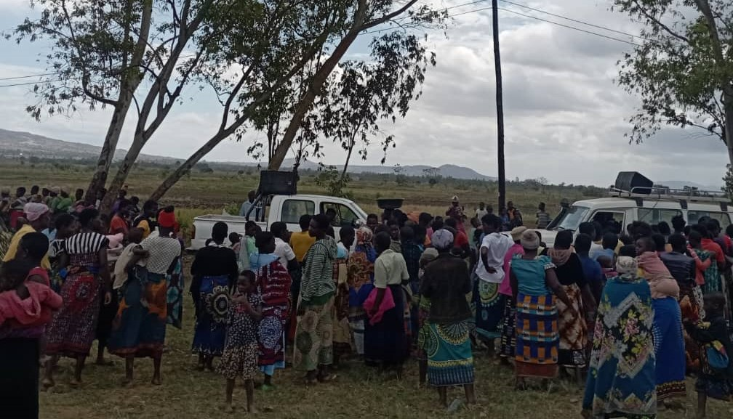

Fig1: Integration of Covid-19 vaccine with family planning service at TA Nkhulambe in Phalombe district

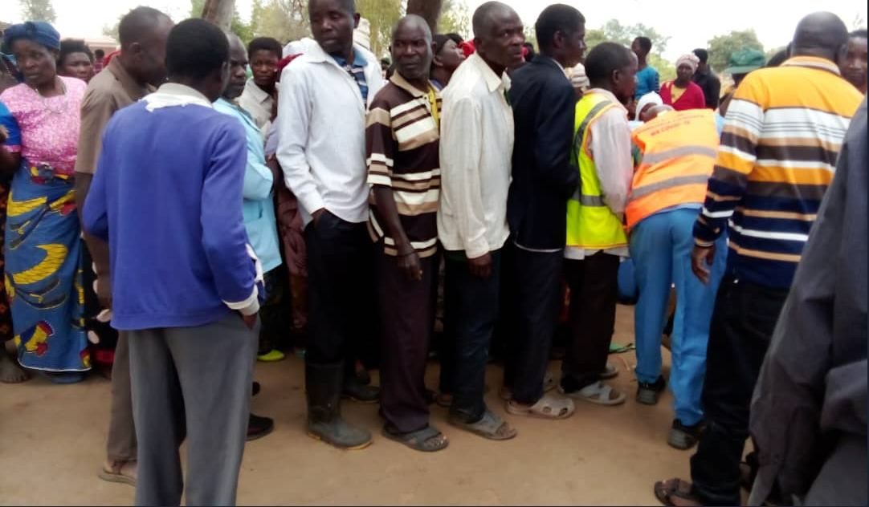
Fig 2: Men receiving Covid-19 vaccines at Gvh Chimombo, T/A Jenala, Phalombe during sensitization and vaccination campaign
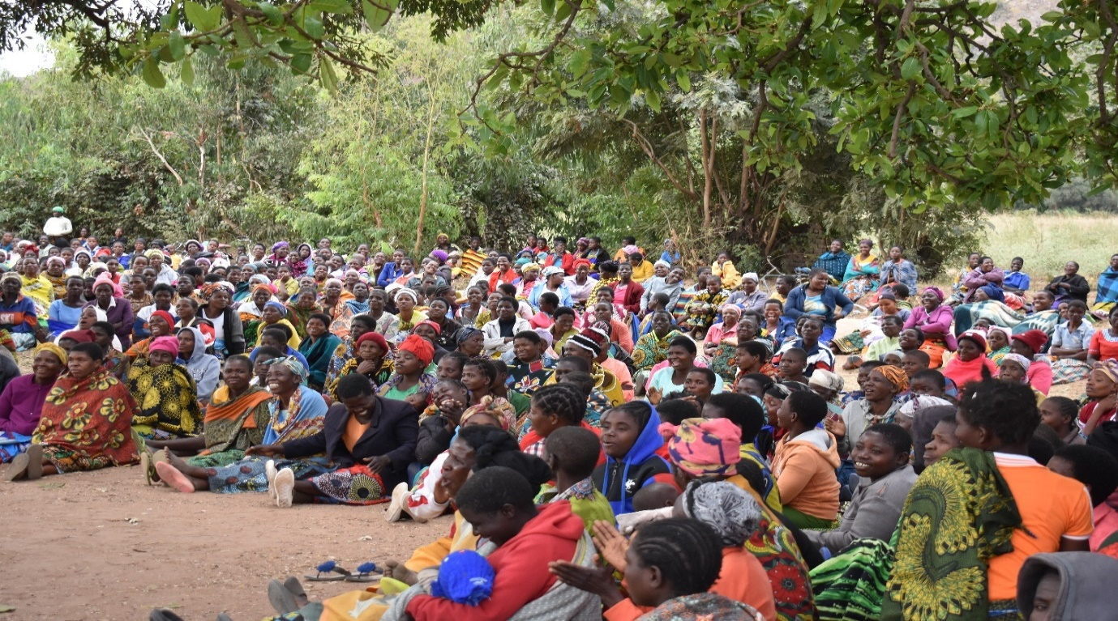

Fig 3: people listening to Covid-19 sensitization messages during community engagement session in Phalombe TA Jenala

\

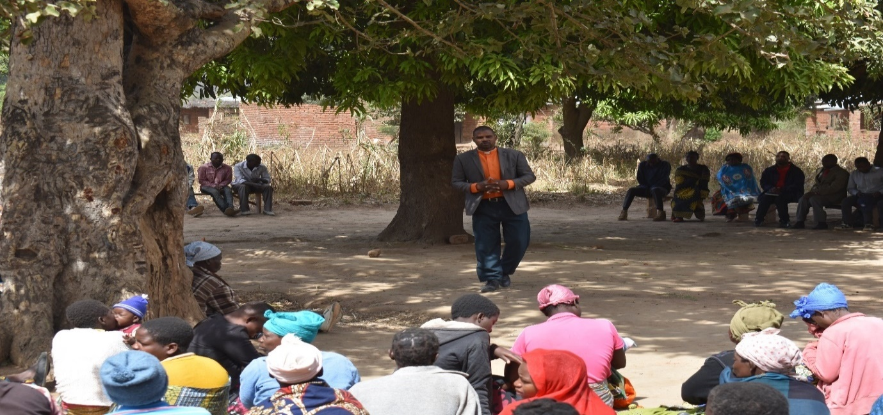

Figure 4: Faith leader participating in community sensitization session demystifying religious related myths
Fig 4: faith leader busting faith related myths about the Covid-19 vaccine in Phalombe district during community engagement
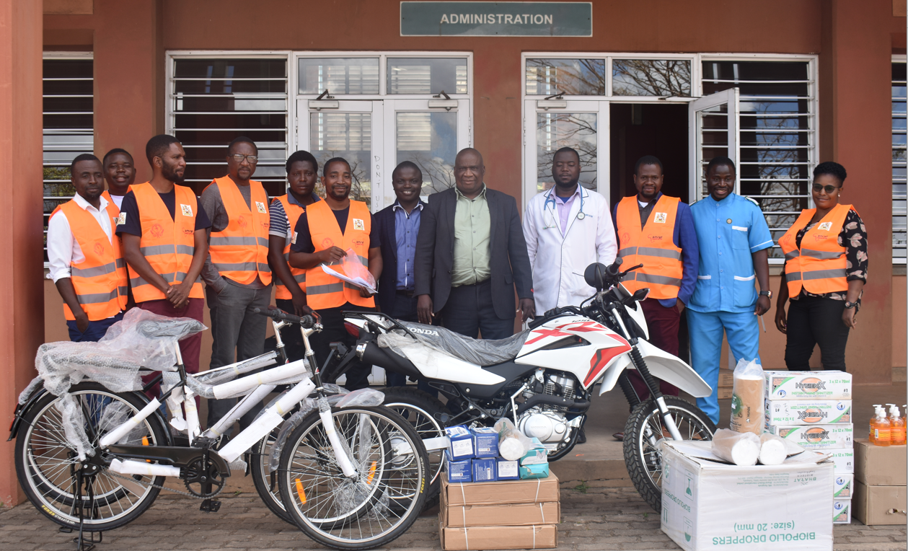
Fig.5: Chiradzulu DHSS receiving VAN project brand new Honda XL motorcycle, 17 buffalo bicycles and assorted medical supplies for strengthening overall immunization programme in the district.
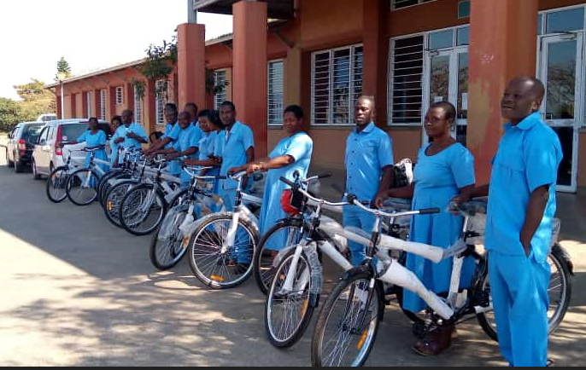
Fig.6: 17 Vaccinators (HSAs) from 17 health facilities receiving VAN project buffalo bicycles for strengthening overall immunization programme in Chiradzulu district
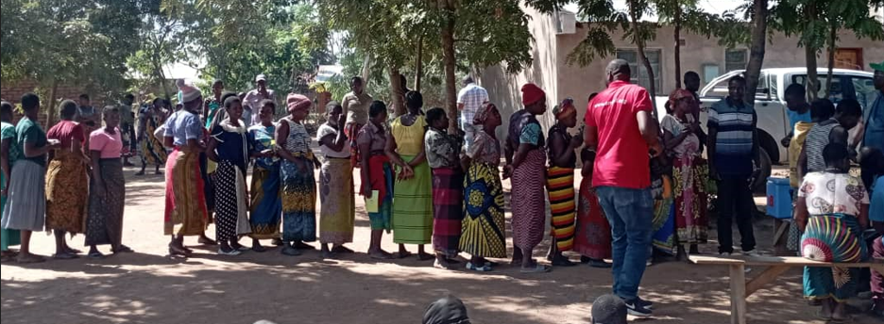
Fig 7: AMREF Team supervising Clients receiving Covid-19 vaccines at Maoni Village, T/A Nkalo, Chiradzulu during sensitization and vaccination campaign
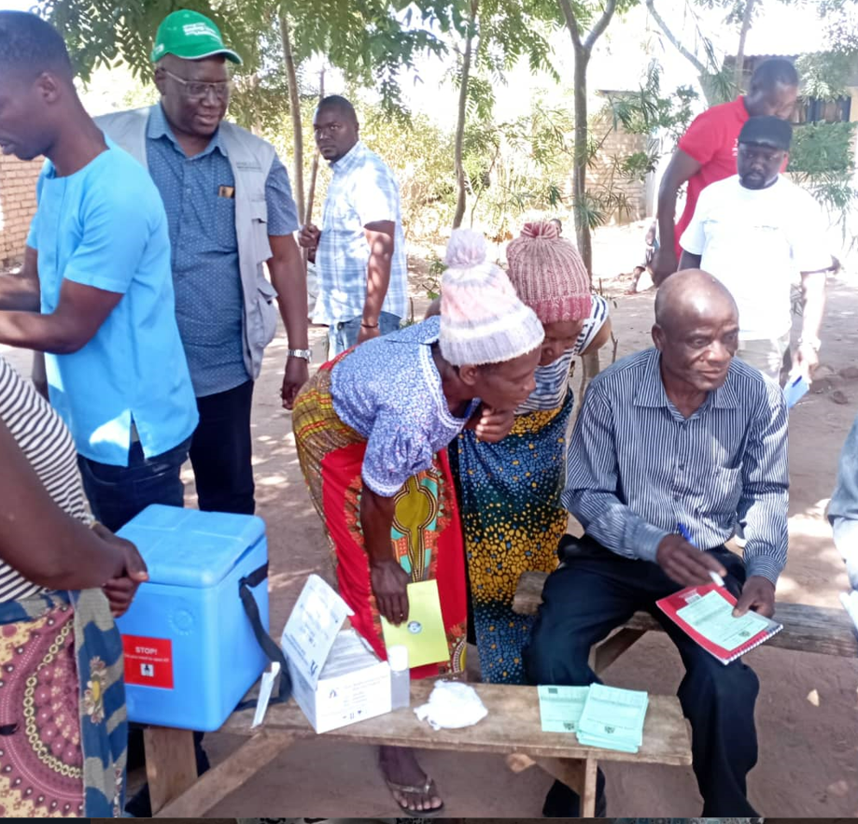Fig 8: AMREF team supervising vaccine administration and documentation of
Clients received Covid-19 vaccines at Maoni Village, T/A Nkalo, Chiradzulu

during sensitization and vaccination campaign

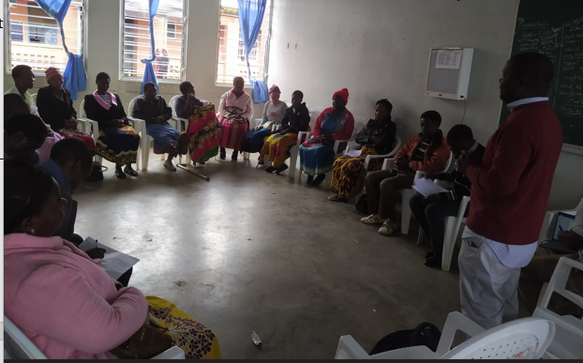
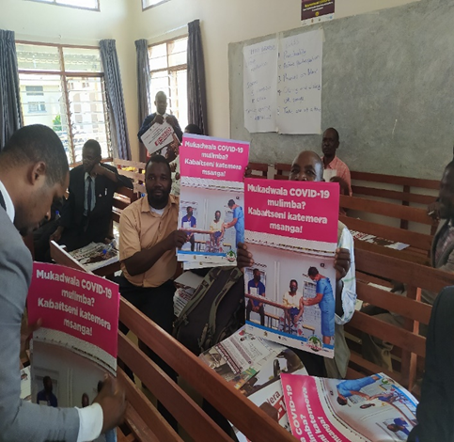

Figure 9: Training of influencers in Chiradzulu District
Figure 10: Training and distribution IEC materials to influencers in Phalombe District

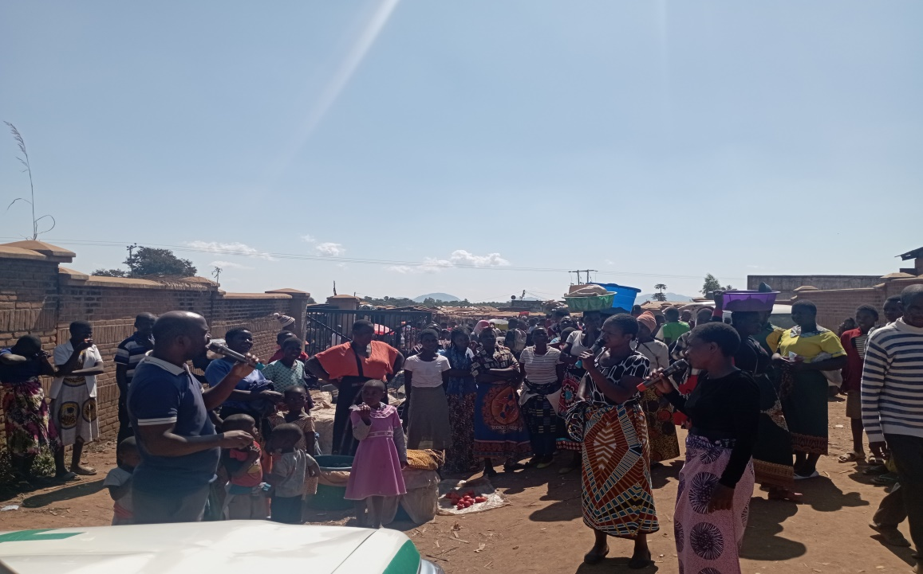

Fig 11. Drama Team Performing at Mbulumbuzi Trading Centre to create demand for Covid-19 Vaccine

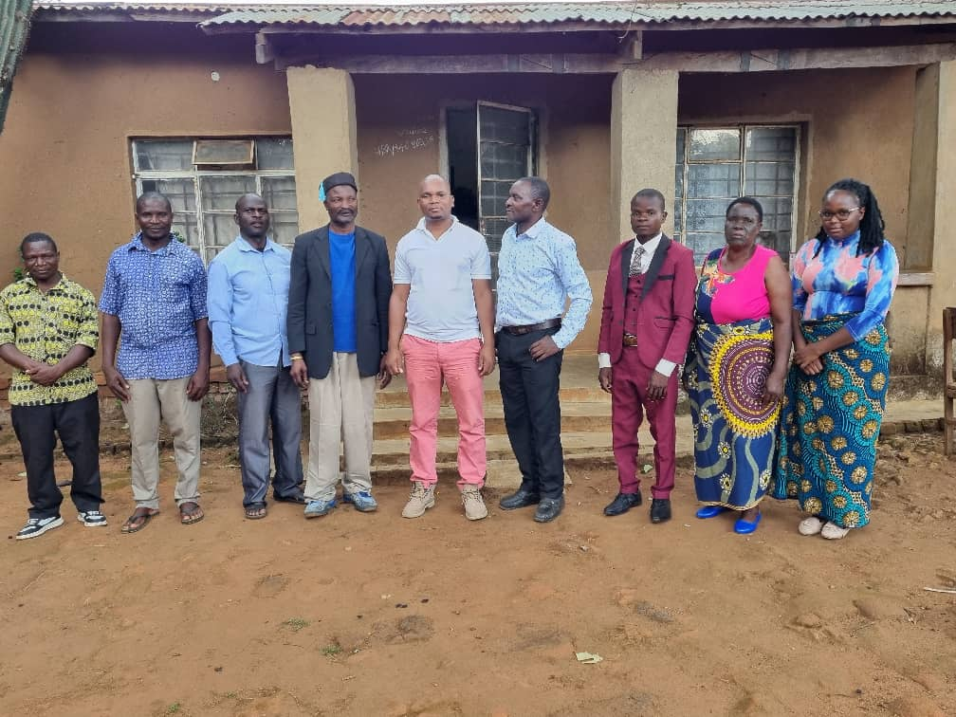
Fig 12. Project team members with participants of an endline survey focus group discussion
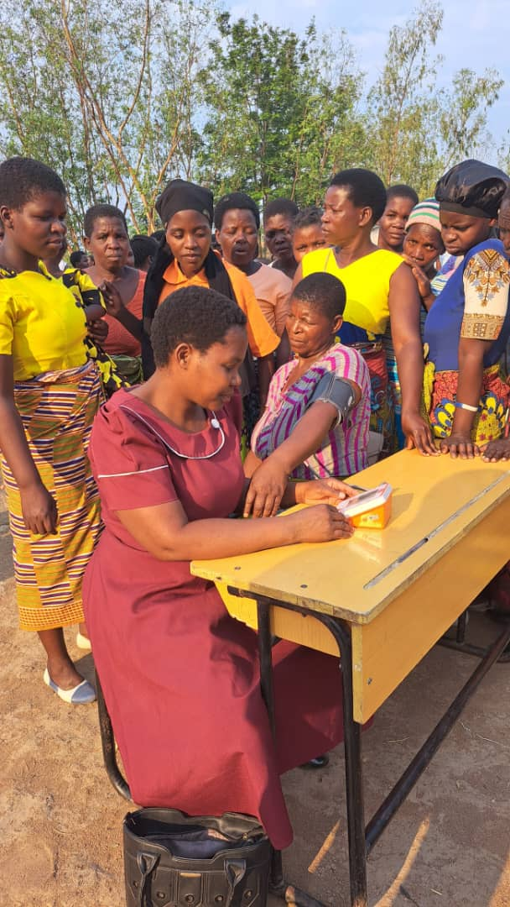
Fig 13. Health worker providing blood pressure screening during an integrated Covid-19 and NCD campaign

